Republic of the Philippines

Department of Finance

For BIR BCS/

Use Only Item:

Bureau of Internal Revenue

BIR Form No.

Certificate of Creditable Tax

Withheld at Source

2307

January 2018 (ENCS)

2307 01/18ENCS

Fill in all applicable spaces. Mark all appropriate boxes with an "X".

1

For the Period

From

(MM/DD/YYYY)

To

(MM/DD/YYYY)

Part I – Payee Information

2

3

Taxpayer Identification Number (TIN)

-

-

-

Payee’s Name (Last Name, First Name, Middle Name for Individual OR Registered Name for Non-Individual)

4

5

Registered Address

4A ZIP Code

Foreign Address, if applicable

Part II – Payor Information

6

7

Taxpayer Identification Number (TIN)

-

-

-

Payor’s Name (Last Name, First Name, Middle Name for Individual OR Registered Name for Non-Individual)

8

Registered Address

8A ZIP Code

Part III – Details of Monthly Income Payments and Taxes Withheld

AMOUNT OF INCOME PAYMENTS

Income Payments Subject to Expanded

Withholding Tax

Tax Withheld for the

Quarter

ATC

1st Month of the

Quarter

2nd Month of the

Quarter

3rd Month of the

Quarter

Total

Total

Money Payments Subject to Withholding

of Business Tax (Government & Private)

Total

We declare under the penalties of perjury that this certificate has been made in good faith, verified by us, and to the best of our knowledge and belief, is true and

correct, pursuant to the provisions of the National Internal Revenue Code, as amended, and the regulations issued under authority thereof. Further, we give our consent to

the processing of our information as contemplated under the *Data Privacy Act of 2012 (R.A. No. 10173) for legitimate and lawful purposes.

Signature over Printed Name of Payor/Payor’s Authorized Representative/Tax Agent

(Indicate Title/Designation and TIN)

Tax Agent Accreditation No./

Date of Issue

Date of Expiry

Attorney’s Roll No. (if applicable)

(MM/DD/YYYY)

(MM/DD/YYYY)

CONFORME:

Signature over Printed Name of Payee/Payee’s Authorized Representative/Tax Agent

(Indicate Title/Designation and TIN)

Tax Agent Accreditation No./

Date of Issue

Date of Expiry

Attorney’s Roll No. (if applicable)

(MM/DD/YYYY)

(MM/DD/YYYY)

*NOTE: The BIR Data Privacy is in the BIR website (www.bir.gov.ph)

{{PAYEES_NAME}}

{{PAYORS_NAME}}

{{ATC_DESC}}

{{PAYEES_REGISTERED_ADDRESS }}

{{PAYORS_REGISTERED_ADDRESS }}

{{TMM}}

{{TDD}}

{{PEZIP}}

{{PRZIP}}

{{PE01}}

{{SIGNATORY}}

{{PR01}}

**{{ATC_CODE}}**

**{{FirstMoQ}}**

**{{SecondMoQ}}**

**{{ThirdMoQ}}**

**{{Total}}**

**{{TWQ}}**

**{{TWQ}}**

{{PR02}}

{{PR03}}

{{PE02}}

{{PE03}}

{{PE04}}

{{PR04}}

{{FYYYY}}

{{FDD}}

{{FMM}}

{{TYYYY}}

Payee’s Name (Last Name, First Name, Middle Name for Individual OR Registered Name for Non-Individual)

{{REGISTERED_ADDRESS }}A

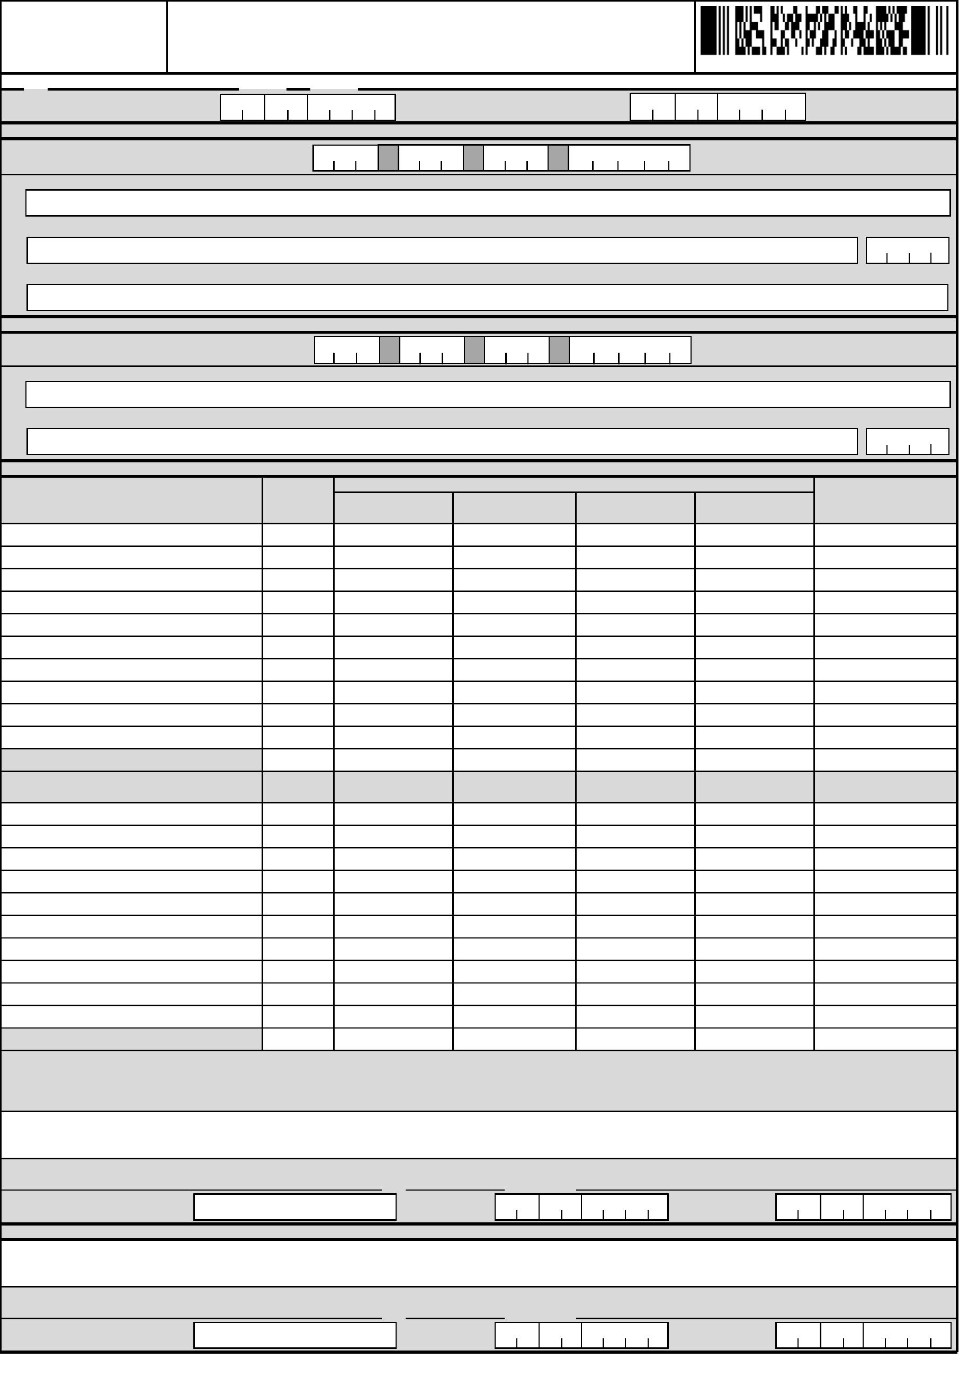

SCHEDULES OF ALPHANUMERIC TAX CODES

ATC

ATC

A

Income Payments subject to Expanded Withholding Tax

A

Income Payments subject to Expanded Withholding Tax

Individual Corporation

Individual Corporation

Professional (Lawyers, CPAs, Engineers, etc.)

Payment by the General Professional Partnerships (GPPs) to its partners

If gross income for the current year did not exceed P 720,000

If gross income exceeds P 720,000

If gross income for the current year did not exceed P 3M

If gross income is more than P 3M or VAT Registered regardless of amount

Professional (Lawyers, CPAs, Engineers, etc.)

WI010

WI011

WI152

WI153

Income payments made by credit card companies

WI156

WC156

If gross income for the current year did not exceed P 720,000

If gross income exceeds P 720,000

WC010

WC011

Additional income payments to government personnel from importers, shipping

and airline companies or their agents for overtime services

WI159

Professional entertainers such as, but not limited to actors and actresses, singers,

lyricist, composers, emcees

If gross income for the current year did not exceed P 3M

If gross income is more than P 3M or VAT Registered regardless of amount

Professional entertainers such as, but not limited to actors and actresses, singers,

lyricists, composers, emcees

Income payments made by the government and government-owned and

controlled corporations (GOCCs) to its local/resident suppliers of goods

other than those covered by other rates of withholding tax

Income payments made by the government and government-owned and

controlled corporations (GOCCs) to its local/resident suppliers of services

other than those covered by other rates of withholding tax

WI640

WI157

WC640

WC157

WI020

WI021

If gross income for the current year did not exceed P 720,000

If gross income exceeds P 720,000

WC020

WC021

Income payment made by top withholding agents to their local/resident supplier

of goods other than those covered by other rates of withholding tax

Income payment made by top withholding agents to their local/resident supplier

of services other than those covered by other rates of withholding tax

Commissions, rebates, discounts and other similar considerations paid/granted to

independent and/or exclusive sales representatives and marketing agents and sub-

agents of companies, including multi-level marketing companies

If gross income for the current year did not exceed P 3M

If gross income is more than P 3M or VAT Registered regardless of amount

Commissions, rebates, discounts and other similar considerations paid/ granted

to independent and/or exclusive sales representatives and marketing agents

and sub-agents of companies, including multi-level marketing companies

If gross income for the current year did not exceed P 720,000

If gross income exceeds P 720,000

WI158

WI160

WC158

WC160

Professional athletes including basketball players, pelotaris and jockeys

If gross income for the current year did not exceed P 3M

If gross income is more than P 3M or VAT Registered regardless of amount

Professional athletes including basketball players, pelotaris and jockeys

If gross income for the current year did not exceed P 720,000

If gross income exceeds P 720,000

All directors and producers involved in movies, stage, radio, television and musical

productions

If gross income for the current year did not exceed P 3M

If gross income is more than P 3M or VAT Registered regardless of amount

All directors and producers involved in movies, stage, radio, television and musical

productions

WI030

WI031

WC030

WC031

WI515

WI516

WI040

WI041

WC515

WC516

If gross income for the current year did not exceed P 720,000

If gross income exceeds P 720,000

Management and technical consultants

WC040

WC041

Gross payments to embalmers by funeral parlors

Payments made by pre-need companies to funeral parlors

Tolling fees paid to refineries

WI530

WI535

WI540

WC535

WC540

If gross income for the current year did not exceed P 3M

If gross income is more than P 3M or VAT Registered regardless of amount

Management and technical consultants

If gross income for the current year did not exceed P 720,000

If gross income exceeds P 720,000

Business and bookkeeping agents and agencies

If gross income for the current year did not exceed P 3M

If gross income is more than P 3M or VAT Registered regardless of amount

Business and bookkeeping agents and agencies

If gross income for the current year did not exceed P 720,000

If gross income exceeds P 720,000

Insurance agents and insurance adjusters

WI050

WI051

Income payments made to suppliers of agricultural products in excess

of cumulative amount of P 300,000 within the same taxable year

Income payments on purchases of minerals, mineral products and quarry

such as but not limited to silver, gold, marble, granite, gravel, sand, boulders

and other mineral products except purchases by Bangko Sentral ng Pilipinas

Income payments on purchases of minerals, mineral products and quarry

resources by Bangko Sentral ng Pilipinas (BSP) from gold miners/suppliers under

PD 1899, as amended by RA No. 7076

On gross amount of refund given by MERALCO to customers with

active contracts as classified by MERALCO

On gross amount of refund given by MERALCO to customers with

terminated contracts as classified by MERALCO

WI610

WC610

WC050

WC051

WI630

WC630

WI060

WI061

WI632

WC632

WI650

WI651

WC650

WC651

WC060

WC061

If gross income for the current year did not exceed P 3M

If gross income is more than P 3M or VAT Registered regardless of amount

Insurance agents and insurance adjusters

If gross income for the current year did not exceed P 720,000

If gross income exceeds P 720,000

Other recipients of talent fees

If gross income for the current year did not exceed P 3M

If gross income is more than P 3M or VAT Registered regardless of amount

Other recipients of talent fees

WI070

WI071

On gross amount of interest on the refund of meter deposit whether paid directly

the customers or applied against customer’s billings of Residential and General

Service customers whose monthly electricity consumption exceeds 200 kwh as

classified by MERALCO

On gross amount of interest on the refund of meter deposit whether paid directly

the customers or applied against customer’s billings of Non- Residential custome

whose monthly electricity consumption exceeds 200 kwh as classified by

MERALCO

On gross amount of interest on the refund of meter deposit whether paid directly

the customers or applied against customer’s billings of Residential and General

Service customers whose monthly electricity consumption exceeds 200 kwh as

classified by other electric Distribution Utilities (DU)

On gross amount of interest on the refund of meter deposit whether paid directly

the customers or applied against customer’s billings of Non-Residential custome

whose monthly electricity consumption exceeds 200 kwh as classified by other

electric Distribution Utilities (DU)

Income payments made by political parties and candidates of local and national

elections on all their purchases of goods and services related to campaign

expenditures, and income payments made by individuals or juridical persons for

their purchases of goods and services intended to be given as campaign

contributions to political parties and candidates

Income payments received by Real Estate Investment Trust (REIT)

Interest income derived from any other debt instruments not within the

coverage of deposit substitutes and Revenue Regulations No. 14-2012

Income payments on locally produced raw sugar

WI660

WI661

WI662

WI663

WC660

WC661

WC662

WC663

WC070

WC071

WI080

WI081

If gross income for the current year did not exceed P 720,000

If gross income exceeds P 720,000

WC080

WC081

Fees of directors who are not employees of the company

If gross income for the current year did not exceed P 3M

If gross income is more than P 3M or VAT Registered regardless of amount

Rentals: On gross rental or lease for the continued use or possession of personal

property in excess of Ten thousand pesos (P 10,000) annually and real property

used in business which the payor or obligor has not taken title or is not taking titl

or in which has no equity; poles, satellites, transmission facilities and billboards

Cinematographic film rentals and other payments to resident individuals and

corporate cinematographic film owners, lessors or distributors

Income payments to certain contractors

Income distribution to the beneficiaries of estates and trusts

Gross commissions or service fees of customs, insurance, stock, immigration and

commercial brokers, fees of agents of professional entertainers and real estate

service Practitioners (RESPs), (i.e. real estate consultants, real estate appraisers

and real estate brokers)

WI090

WI091

WI100

WC100

WI680

WI710

WC680

WI110

WC110

WC120

WI120

WI130

WC690

WC710

WI720

WI555

WI556

WI557

WI558

WC720

WC555

WC556

WC557

WC558

Sale of Real Property (Ordinary Asset)

1.50%

3%

If gross income for the current year did not exceed P 3M

If gross income is more than P 3M or VAT Registered regardless of amount

Gross commissions or service fees of customs, insurance, stock, immigration and

commercial brokers, fees of agents of professional entertainers and real estate

service Practitioners (RESPs), (i.e. real estate consultants, real estate appraisers

and real estate brokers)

WI139

WI140

5%

6%

B Money Payments Subject to Withholding of Business Tax by Government or Private

Payor (Individual & Corporate)

Persons Exempt from VAT under Sec. 109BB (creditable)-Government Withholdin

WB080

WB082

If gross income for the current year did not exceed P 720,000

If gross income exceeds P 720,000

WC139

WC140

Agent

Persons Exempt from VAT under Sec. 109BB (creditable)-Private Withholding

Agent

VAT Withholding on Purchases of Goods (with waiver of privilege to claim input t

credit) (creditable)

VAT Withholding on Purchases of Services (with waiver of privilege to claim input

tax credit) (creditable)

Professional fees paid to medical practitioners (includes doctors of medicine,

doctors of veterinary science & dentists) by hospitals & clinics or paid directly by

Health Maintenance Organizations (HMOs) and/or similar establishments

If gross income for the current year did not exceed P 3M

If gross income is more than P 3M or VAT Registered regardless of amount

Professional fees paid to medical practitioners (includes doctors of medicine

doctors of veterinary science & dentists) by hospitals & clinics or paid directly by

Health Maintenance Organizations (HMOs) and/or similar establishments

If gross income for the current year did not exceed P 720,000

If gross income exceeds P 720,000

WV012

WI151

WI150

WV022

WC151

WC150

C Money Payments Subject to Withholding of Business Tax by Government Payor Only

Tax on Carriers and Keepers of Garages

Franchise Tax on Gas and Utilities

WB030

WB040

Tax on Other Non-Banks Financial Intermediaries not Performing Quasi-Banking

Functions

Franchise Tax on radio & radio & TV broadcasting companies whose annual gross receipts do

not exceed P10M & who are not VAT-registered taxpayers

Tax on Life Insurance Premiums

Tax on Overseas Dispatch, Message or Conversation from the Philippines

Tax on Banks and Non-Bank Financial Intermediaries Performing Quasi Banking Functions

A. On interest, commissions and discounts from lending activities as well as income from financial

leasing, on the basis of the remaining maturities of instrument from which such receipt are derived

A.

On interest, commissions and discounts from lending activities as well as Income

WB050

WB070

WB090

from financial leasing, on the basis of the remaining maturities of instrument from

which such receipt are derived

-

-

Maturity period is five years or less

5%

1%

5%

WB108

WB109

WB110

WB140

Maturity period is more than five years

B.

On all other items treated as gross income under the code

Tax on Cockpits

-

-

Maturity period is five years or less

Maturity period is more than five years

5%

1%

0%

WB301

WB303

WB102

Tax on amusement places, such as cabarets, night and day clubs, videoke bars, karaoke bars,

karaoke television, karaoke boxes, music lounges and other similar establishments

Tax on Boxing exhibitions

Tax on Professional basketball games

Tax on jai-alai and race tracks

WB150

B. On dividends and equity shares and net income of subsidiaries

C. On royalties, rentals of property, real or personal, profits from exchange

and all other items treated as gross income under the Code

D. On net trading gains within the taxable year on foreign currency, debt

securities, derivatives and other similar financial instruments

Business tax on Agents of Foreign Insurance Companies - Owner of the Property

Tax on International Carriers

Business Tax on Agents of Foreign Insurance Companies - Insurance Age

Business Tax on Agents of Foreign Insurance Companies - Owner of the Property

Tax on International Carriers

WB160

WB170

WB180

WB200

7%

7%

WB103

Tax on sale, barter or exchange of stocks listed and traded through Local Stock exchange

Tax on shares of stock sold or exchanged through initial and secondary public offering

WB104

WB121

WB130

WB120

WB121

WB130

-

-

-

Not over 25%

Over 25% but not exceeding 33 1/3%

Over 33 1/3%

4%

2%

1%

WB201

WB202

WB203

